**20.LOGICAL OPERATIONS**  
  
**AIM:**To compute various logical operations using 8085 processor.

**SOFTWARE REQUIREMENTS:**

GNUSIM 8085  
**ALGORITHM:**  
1)      Load data to accumulator.  
2)      Load another data in register.  
3)      Perform logical operations like AND, OR and XOR (Use ANA, ORA, XRA) with the accumulator content.  
4)      Store the result in specified memory location.  
  
**PROGRAM:**  
 **AND OPERATION:**  
MVI A,06  
MVI B,04  
ANA B  
STA 2500  
HLT  
  
**OR OPERATION:**  
MVI A,07  
MVI B,06  
ORA B  
STA 2000  
HLT  
  
**XOR OPERATION:**  
MVI A,03  
MVI B,08  
XRA B  
STA 2000  
HLT  
  
**INPUT:**  
  
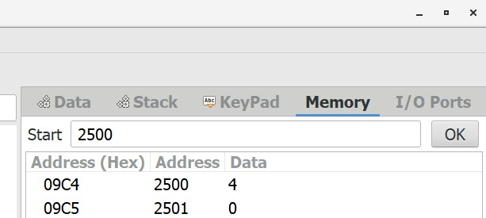   
  
  
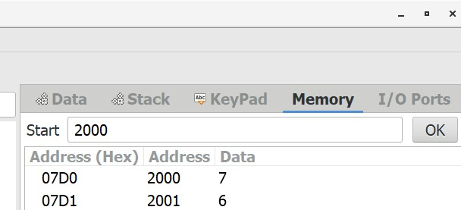  
  
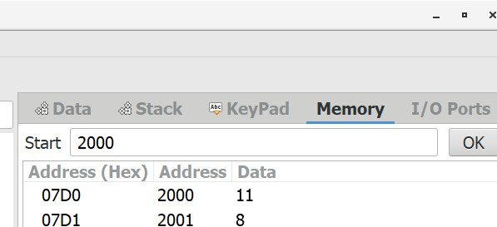  
  
  
  
  
**OUTPUT:**  
  
  
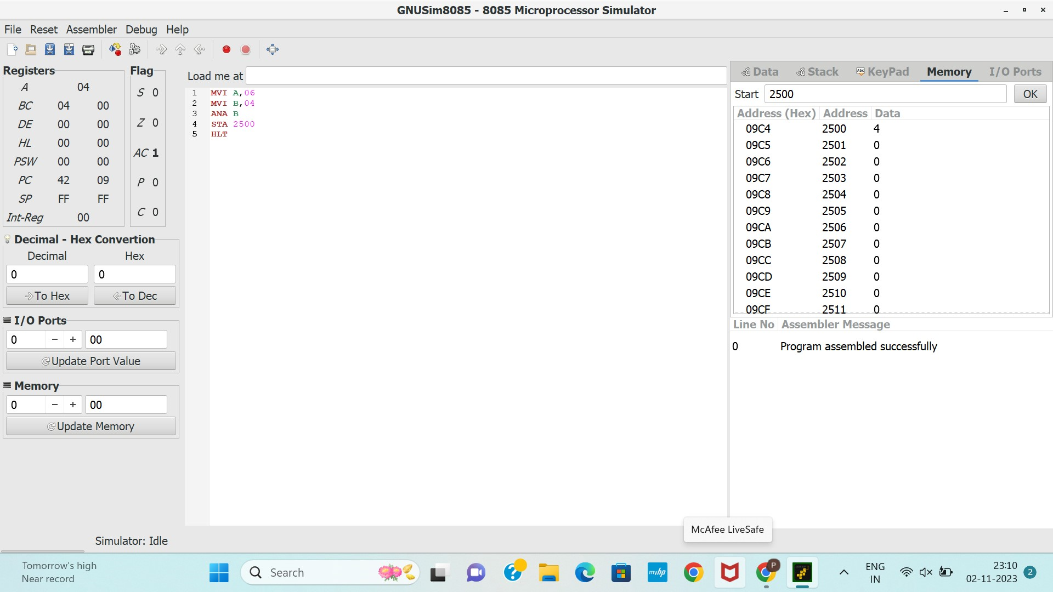 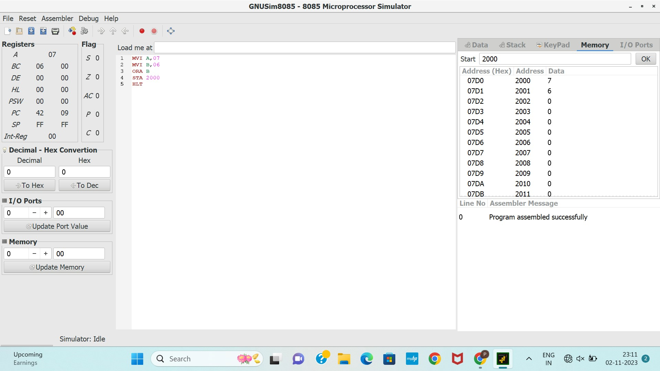 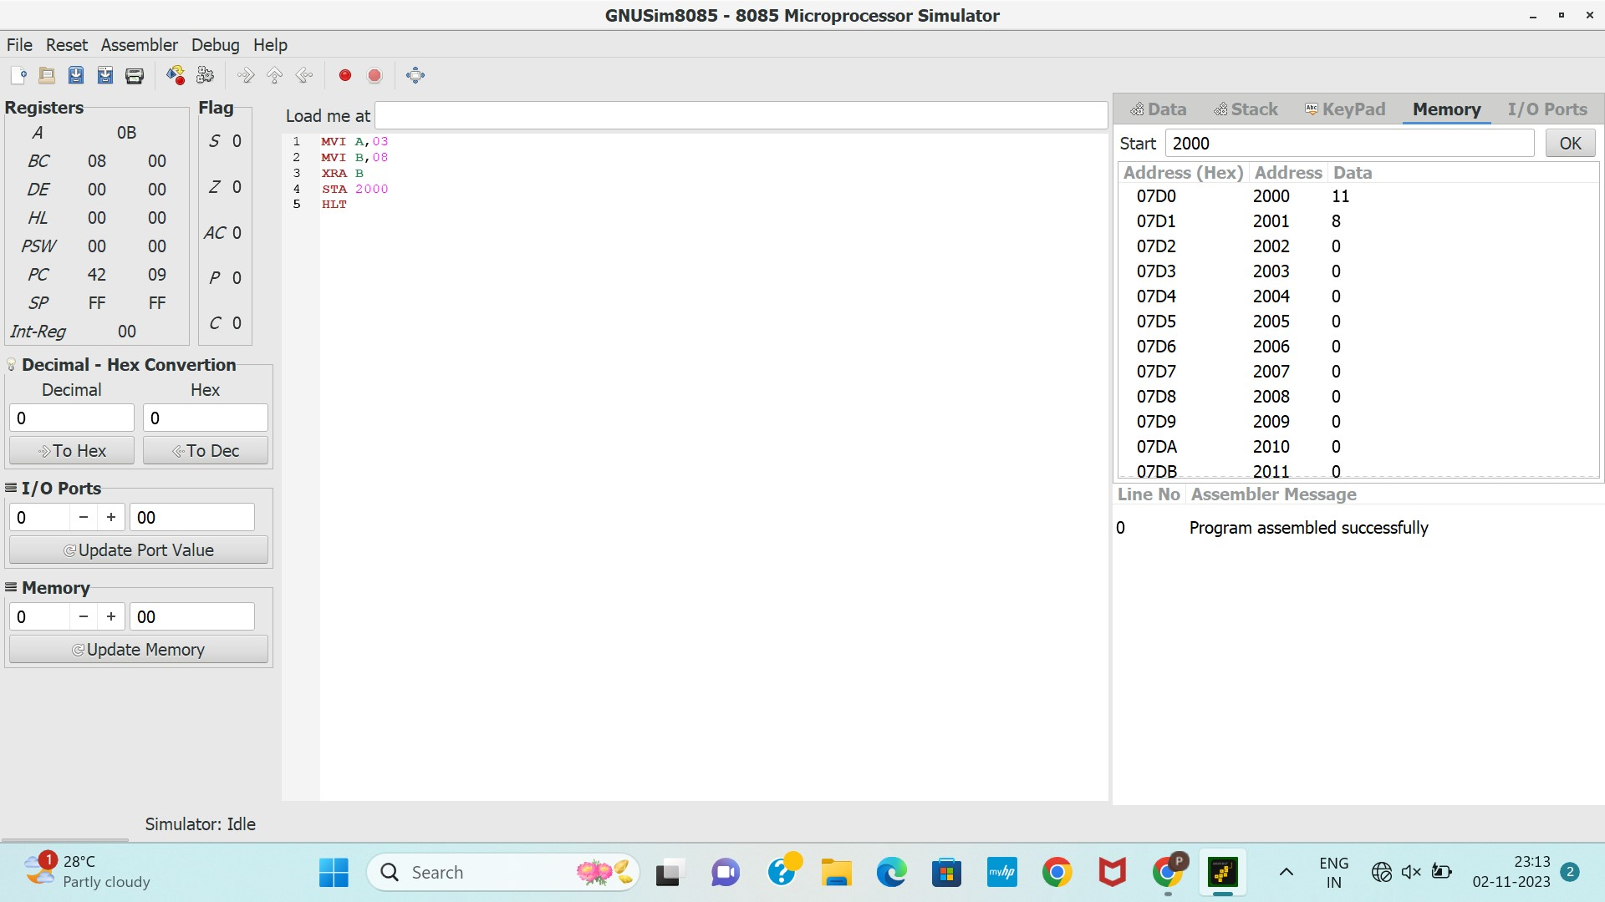  
  
  
  
  
  
  
  
  
  
  
  
  
  
  
  
  
  
  
  
  
  
  
  
  
  
  
  
  
  
  
  
  
  
  
  
  
  
  
  
  
  
  
  
  
  
  
  
  
  
  
  
  
  
  
  
  
  
  
  
  
  
  
  
  
  
  
  
  
  
  
  
  
  
  
  
  
**RESULT:**Thus the program was executed successfully using 8085 processor simulator.